**TINSUKIA COLLEGE**

**PROJECT REPORT**

ON

“Online Supplements Store”

SUBMITTED TO

DEPARTMENT OF COMPUTER APPLICATION



IN PARTIAL FULLFILMENT

OF THE DEGREE OF

BACHELOR OF COMPUTER APPLICATION (BCA)

Session (2024-25)

By

Name: Biki Kumar Prasad

Roll No: 11420006  
Registration No: 22668976

Centre for I.T Studies

Tinsukia College

AFFILIATED TO DIBRUGARH UNIVERSITY

Accredited by NAAC with B+ grade

CERTIFICATE OF COMPLETION

This is to certify that the project work titled **“Online Supplements Store”**, submitted by **Biki Kumar Prasad** (Roll No: 11420006 & Registration No: 22668976), a student of **BCA 5th Semester, Tinsukia College**, affiliated to **Dibrugarh University**, has been successfully completed under my guidance. This project work is submitted in partial fulfilment of the requirements for the **Minor Project of Bachelor of Computer Applications (BCA)**.

The work embodied in this project is original and has been carried out with sincerity and diligence by the student. It has met the necessary standards as per the guidelines of the curriculum.

I extend my best wishes to him for all future academic and professional endeavours.

Date:

Tinsukia College, Tinsukia, Assam

Co-Ordinator for IT studies

Mr. Farooq Hussain

Centre for I.T Studies

Tinsukia College

AFFILIATED TO DIBRUGARH UNIVERSITY

Accredited by NAAC with B+ grade

CERTIFICATE OF COMPLETION

This is to certify that the project work titled **“Online Supplements Store”**, submitted by **Biki Kumar Prasad** (Roll No: 11420006 & Registration No: 22668976), a student of **BCA 5th Semester, Tinsukia College**, affiliated to **Dibrugarh University**, has been successfully completed under my guidance. This project work is submitted in partial fulfilment of the requirements for the **Minor Project of Bachelor of Computer Applications (BCA)**.

The work embodied in this project is original and has been carried out with sincerity and diligence by the student. It has met the necessary standards as per the guidelines of the curriculum.

I extend my best wishes to him for all future academic and professional endeavours.

Date:

Tinsukia College, Tinsukia, Assam

INTERNAL EXAMINER

EXTERNAL EXAMINER

Acknowledgement

It is with immense pleasure and heartfelt gratitude that we take this opportunity to express our deepest appreciation to all those who made this project possible.

First and foremost, we extend our sincere thanks to our esteemed Principal, **Prof. Dr. Surjya Chutiya**, Tinsukia College, for providing us with the necessary facilities and an environment conducive to learning and research. His leadership and encouragement have been a guiding light throughout our academic journey.

We are profoundly thankful to **Prof. MD Farooq Hussain**, Head of the Department of Computer Science and Centre for Information Technology Studies, Tinsukia College, for his unwavering support and constructive guidance. His invaluable insights and encouragement have greatly enriched our project.

A special note of gratitude goes to our Internal Assistant Professor, **Mrs. Pooja Sharma**, Department of Computer Science, whose constant motivation, support, and expert advice have been a source of inspiration. Her patience and valuable suggestions at every stage of our work have been instrumental in the successful completion of this project.

We also extend our sincere thanks to the **departmental staff members, lab technicians, and non-teaching staff** of the Computer Science Department, Tinsukia College, for their assistance and cooperation throughout our project journey. Their behind-the-scenes efforts have played a pivotal role in ensuring smooth progress.

Our heartfelt thanks are also due to our peers and friends, whose camaraderie, insights, and encouragement have been a source of strength during this endeavour. Their support and constructive feedback have inspired us to aim higher and work harder.

Lastly, we owe an enormous debt of gratitude to our families for their unconditional support, patience, and love, which have been our backbone throughout this journey. Their belief in our capabilities has driven us to put forth our best effort.

This project has been an incredible learning experience, and we are grateful for the collective support and encouragement that have helped us bring this endeavour to fruition.

Biki Kumar Prasad

BCA 5th Semester

Reg No: 22668976

Roll No: 11420006

Declaration

I, Biki Kumar Prasad, a student of Bachelor of Computer Application (BCA), 5th Semester, Tinsukia College, hereby declare that the project work titled **"Online Supplements Store"** is an original work carried out by me under the guidance of **Prof. MD Farooq Hussain** & **Mrs. Pooja Sharma**.

This project has been undertaken as a part of the curriculum for the partial fulfilment of the requirements for the Bachelor of Computer Application degree, as prescribed by Dibrugarh University. The content presented in this project report is original and has not been submitted to any other institution or university for the award of any degree or diploma.

All sources of information used have been duly acknowledged in the References section of this report.

I take full responsibility for the integrity and authenticity of the work submitted in this project.

Biki Kumar Prasad

Registration No: 22668976

Roll No: 11420006

Date:

Abstract

The **Online Supplements Store** is a web-based application aimed at simplifying access to fitness and nutritional supplements for health enthusiasts and athletes. This platform offers an extensive range of products, including pre-workout supplements, protein powders, vitamins, and other fitness-oriented items, catering to the diverse needs of customers.

The primary objective of the project is to create an intuitive and visually appealing website that ensures smooth navigation and effective user engagement. Built using technologies like HTML, CSS, and JavaScript, the store features a responsive design, informative product pages, and an organized layout to enhance the browsing experience. Additional focus is placed on the importance of presenting detailed product descriptions, health benefits, and usage recommendations to empower users in making informed choices.

The platform not only bridges the gap between customers and quality supplements but also highlights the potential of digital solutions in the fitness and health domain. By offering a convenient, reliable, and comprehensive online marketplace, this project aims to address the increasing demand for health and fitness products, promoting a healthier lifestyle for its users.

Table of Contents

Introduction 1

Objective 2

Background of the Project 3

Problem Statement 3

System Analysis/ Problem Analysis 4

Problem Analysis 4

Proposed System Analysis 5

System Benefits 6

System Flow 7

User Flow 8

Database Design 9

Products 9

Cart 9

Implementation 10

HTML 10

CSS Implementation 12

JavaScript Implementation 13

Using JSON for data Storage 16

Challenges faced during implementation 18

Conclusion 19

Results 20

Home page 20

About page 21

Contact page 22

User Account page 23

Empty Cart view 24

Added items in cart view 24

Product Detail view 25

Conclusion 26

References/ Bibliography 27

# Introduction

Health and fitness are vital aspects of modern life, with growing awareness among individuals about the importance of a balanced diet, regular exercise, and proper supplementation. In a fast-paced world, where time is a constraint, accessing fitness products and supplements conveniently is crucial for enthusiasts and professionals alike.

The **Online Supplements Store** is an e-commerce platform designed to meet the needs of individuals seeking high-quality fitness supplements. It bridges the gap between accessibility and affordability by offering a wide range of products, including protein powders, pre-workout supplements, vitamins, and other nutrition essentials. The platform is specifically crafted to cater to users looking for reliable, verified supplements delivered to their doorstep with ease.

Unlike traditional retail shopping, the Online Supplements Store empowers users with detailed product information, personalized recommendations, and the ability to compare multiple products at their convenience. This platform also fosters a growing community of fitness enthusiasts, offering them a one-stop solution to fulfil their nutritional requirements.

This initiative aims to support the fitness community by providing a robust and interactive platform for purchasing supplements. With features like detailed descriptions, user reviews, and timely delivery, the store ensures users receive quality products, fostering a healthier and more active society.

## Objective

The **Online Supplements Store** aims to provide a seamless and user-friendly platform where fitness enthusiasts and health-conscious individuals can explore and purchase nutritional products from the comfort of their homes. The key objectives of the project are as follows:

* **Develop a User-Friendly Interface**: To create an intuitive and easy-to-navigate web-based interface where users can effortlessly browse, search, and view a wide range of fitness supplements, including pre-workout supplements, protein powders, and vitamins.
* **Facilitate Convenient Shopping**: To enable users to purchase supplements from the comfort of their homes, ensuring convenience and saving time compared to traditional shopping methods.
* **Provide Detailed Product Information**: To display complete descriptions, usage instructions, and benefits of each product to help users make informed purchasing decisions.
* **Promote Health and Fitness Awareness**: To support the fitness community by offering verified, high-quality products and encouraging healthier lifestyles.
* **Ensure Accessibility and Availability**: To make supplements and fitness products accessible to users in Tinsukia and beyond, with a reliable delivery system that ensures prompt service.
* **Incorporate a Query System**: To include a feature allowing users to ask questions or seek guidance on selecting the right supplements for their fitness goals.

By meeting these objectives, the platform aims to simplify the process of purchasing fitness supplements, fostering a healthier and more active society.

## Background of the Project

The rapid growth of e-commerce has transformed the way people shop, bringing convenience and accessibility to their fingertips. In the health and fitness sector, the demand for nutritional supplements has grown significantly, driven by an increasing awareness of personal fitness and wellness. However, access to a reliable and comprehensive platform that offers quality supplements tailored to individual needs remains a challenge in smaller towns like Tinsukia.

The Online Supplements Store aims to bridge this gap by creating a dedicated platform that caters to the fitness needs of users, offering a variety of nutritional products, including protein powders, pre-workout supplements, vitamins, and more. This initiative is inspired by the lack of local platforms that provide access to verified, affordable, and high-quality fitness supplements. The project seeks to promote a healthier lifestyle by simplifying the process of purchasing supplements while educating users about their benefits.

## Problem Statement

In Tinsukia and similar regions, individuals pursuing fitness goals often face the following challenges:

1. **Limited Accessibility to Quality Supplements**: Many fitness enthusiasts lack access to a variety of reliable supplements, as most products are either unavailable locally or expensive when sourced from distant suppliers.
2. **Lack of Information**: Users often struggle to find clear, accurate information about supplements, leading to confusion and potential misuse.
3. **Time and Effort**: The conventional method of buying supplements involves traveling to physical stores, which is time-consuming and inconvenient.
4. **Absence of a Comprehensive Platform**: There is no single platform where users can browse a diverse range of supplements, compare options, and make informed decisions.

By addressing these problems, the **Online Supplements Store** project aims to offer a reliable, convenient, and informative solution that meets the fitness and nutritional needs of its users efficiently.

# System Analysis/ Problem Analysis

The **Online Supplements Store** project emerges from a critical analysis of the challenges faced by users in accessing reliable fitness supplements and nutritional products. This analysis examines the limitations of the current system, evaluates user needs, and identifies the technological solutions required to address them effectively.

## Problem Analysis

**Existing System and Challenges**

1. **Physical Stores**:
   * Limited inventory with insufficient variety to meet the diverse requirements of users.
   * Supplements in smaller towns like Tinsukia are often overpriced due to supply chain constraints.
   * Accessibility issues for users who may not have stores nearby.
2. **Non-Specialized E-Commerce Platforms**:
   * While platforms like Amazon and Flipkart offer supplements, they often lack detailed and trusted guidance specific to fitness needs.
   * Users may encounter counterfeit products without proper quality assurance.
   * Personalized support or recommendations are unavailable.
3. **Informational Gaps**:
   * Fitness enthusiasts often struggle to find accurate and easy-to-understand details about supplement benefits and usage.
   * Potential risks of using unverified supplements without proper guidance.

**User Requirements**

* A dedicated, trustworthy platform offering quality-assured fitness supplements.
* A simple and user-friendly interface for browsing, comparing, and purchasing products.
* Access to comprehensive product descriptions, including benefits, usage instructions, and potential side effects.
* Support for resolving queries related to fitness and supplement usage.

## Proposed System Analysis

**Key Features**

1. **E-Commerce Functionality**:
   * A platform where users can browse products categorized by type (e.g., pre-workout, vitamins, proteins).
   * Search and filter options for efficient navigation.
2. **Product Information**:
   * Each product listing includes detailed descriptions, reviews, ratings, and recommended usage guidelines.
   * Content designed to educate users on making informed choices.
3. **User Interaction**:
   * Recommendation feature based on user preferences and fitness goals.
4. **Local Focus**:
   * Delivery services optimized for Tinsukia and nearby areas to ensure quick and reliable service.
   * Affordability with competitive pricing and discounts tailored for local users.

## System Benefits

* **Accessibility**: Users can order supplements from the comfort of their homes without the hassle of visiting physical stores.
* **Reliability**: The platform ensures authenticity by sourcing products only from trusted manufacturers and suppliers.
* **User-Centric Approach**: Simplifies the supplement-buying experience while promoting fitness education and awareness.

By addressing the above gaps, the system aims to create a seamless, dependable, and informative platform that enhances the user's experience in purchasing fitness supplements.

**System Architecture**

The system architecture follows a **1-Tier Architecture**, ensuring separation of concerns for better scalability and maintainability.

1. **Presentation Layer (Frontend)**:
   * Built using **HTML, CSS, and JavaScript** to provide an interactive and responsive user interface.
   * Users can browse products, view product details, search/filter items, and place orders.

# System Flow

# User Flow

# Database Design

## Products

|  |  |  |
| --- | --- | --- |
| **Key** | **Type** | **Description** |
| product_id | INT | Unique identifier for products. |
| name | STRING | Product name. |
| category | STRING | Product category (e.g., pre-workout). |
| price | DOUBLE | Discounted Price of the product. |
| cross_price | DOUBLE | Original Price of the product |
| stock_quantity | INT | Quantity available in stock. |
| description | STRING | Detailed description. |

## Cart

|  |  |  |
| --- | --- | --- |
| **Key** | **Type** | **Description** |
| Item_id | Int | ID of the product |
| data | Obj | Object data of the product |

# Implementation

The "Online Supplements Store" project is a simple e-commerce website created to allow users to browse and purchase fitness supplements. The project is built using a combination of **HTML**, **CSS**, and **JavaScript**. Since the project is a minor one, it doesn't include server-side implementation or a back-end database, focusing mainly on the front-end aspect of the application.

## HTML

HTML (Hypertext Markup Language) forms the structure of the website. The various components of the project, such as the homepage, product listing, and the cart page, are created using HTML.

1. **Home Page**: The home page contains a navigation bar for easy access to other sections of the site. It features a list of available fitness supplements, including their names, descriptions, and images. Each product is displayed within a div element, which is styled using CSS to give it a card-like appearance.
   * The products are contained within a section with the <section> tag. The use of <div> tags within each product allows for easy positioning of product names, descriptions, and prices.
   * 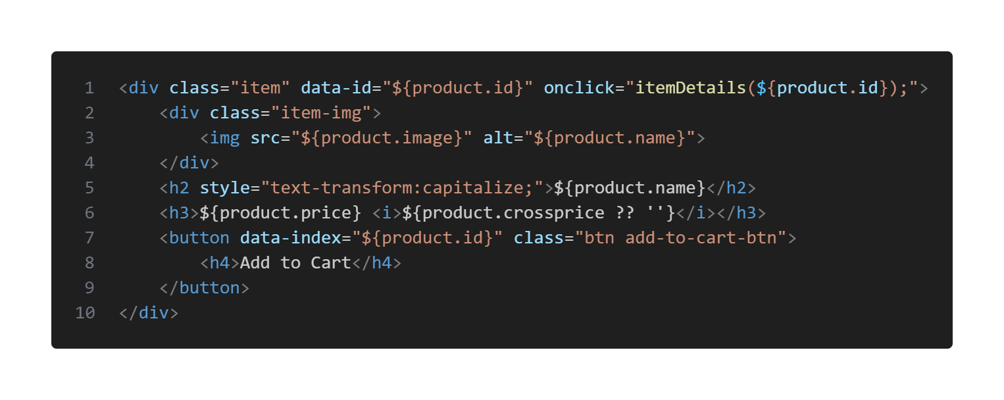Basic elements like <h1>, <h2>, <p>, and <img> are used for headings, descriptions, and product images.

The JavaScript is used to render the products from a Json file to get the pre-defined product data provided at the beginning. Then with the help of the scripts, each product with its respective details and information is shown to the screen which is appended to the document via DOM (Document Manipulation).

The above code shows how the products are loaded from the Json file and rendered to the document. The jQuery dependency has been used in this project to maximise results and reduce code.

1. 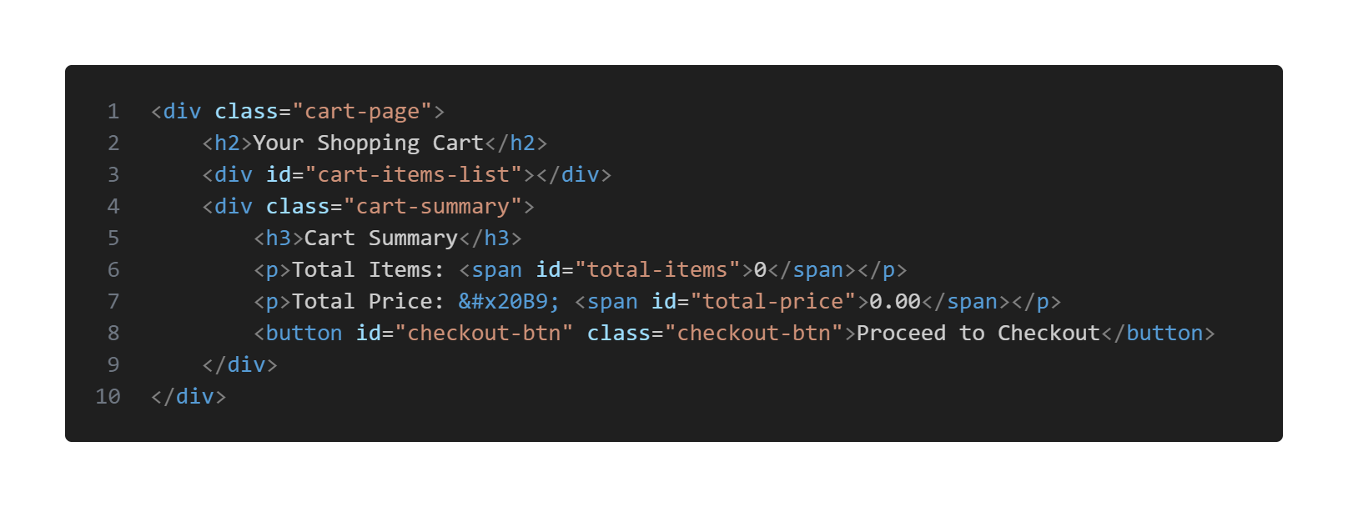**Cart Page**: A cart page displays the items added to the shopping cart, allowing the user to view the quantity and total price of selected products. It is created with a simple **<div>** to list out each individual items using JavaScript. Then they are rendered inside the **“.cart-items-list”** by appending the result of data fetched by the Indexed database.
2. **Items Detail Page**: The products details and descriptions are shown in an HTML page which includes only the rough template for the content where the script would later load the data by appending and fetching contents from a database or file.

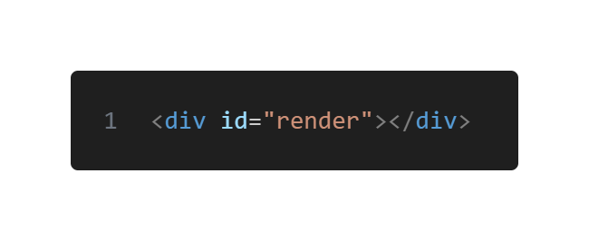

## CSS Implementation

CSS (Cascading Style Sheets) is used to style the website, ensuring a visually appealing and user-friendly interface. The goal is to create a clean and organized layout that promotes easy navigation and improves the user experience.

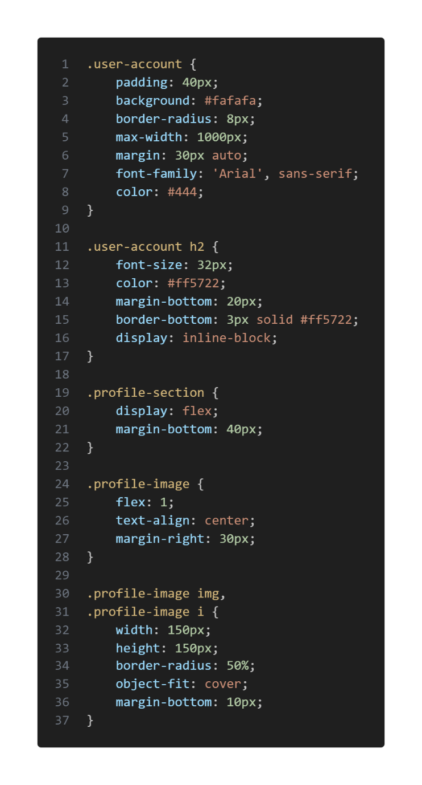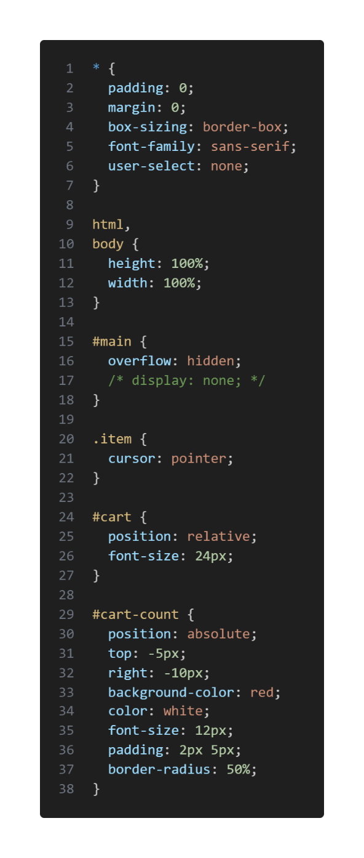

The webpage uses CSS to style the pages and achieve a better look and feel that is important for a great user experience and boost traffic to the page. Easier and better styling enables people to navigate and use the platform more freely and easily without any issues and this makes sure that the users can look for what they want easier.

## JavaScript Implementation

JavaScript is used to add interactivity to the website, such as adding products to the shopping cart, calculating the total price, and updating quantities.

1. **Adding Items to the Cart**: When a user clicks the "Add to Cart" button, the item is added to the cart. A JavaScript function listens for the button click and adds the product information (name, price, quantity) to an array representing the cart.

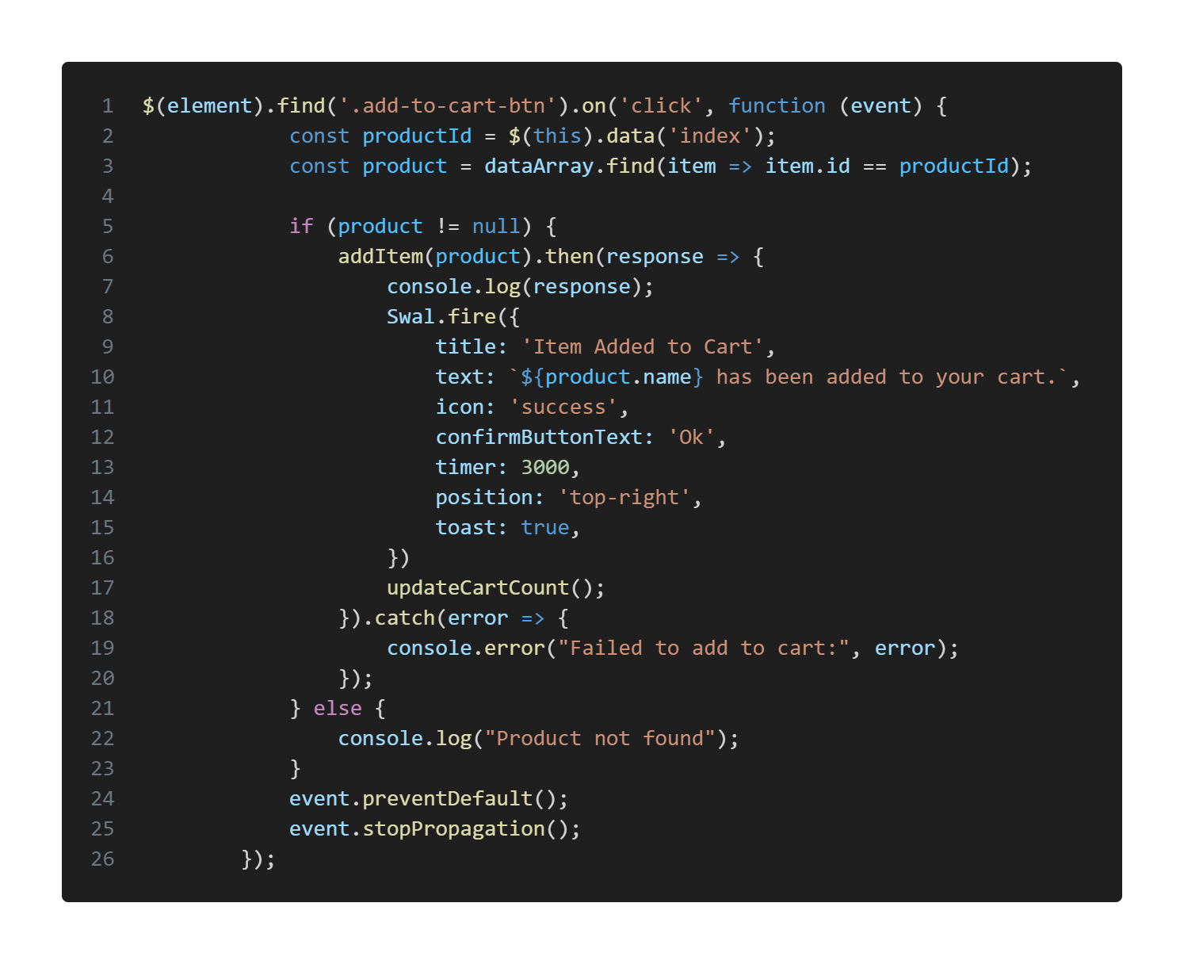Example JavaScript for adding items to the cart:

1. **Updating the cart**: The cart is updated in real-time whenever a user modifies the quantity of an item or adds/removes items. JavaScript dynamically modifies the cart's HTML content by appending or removing rows in the cart table.

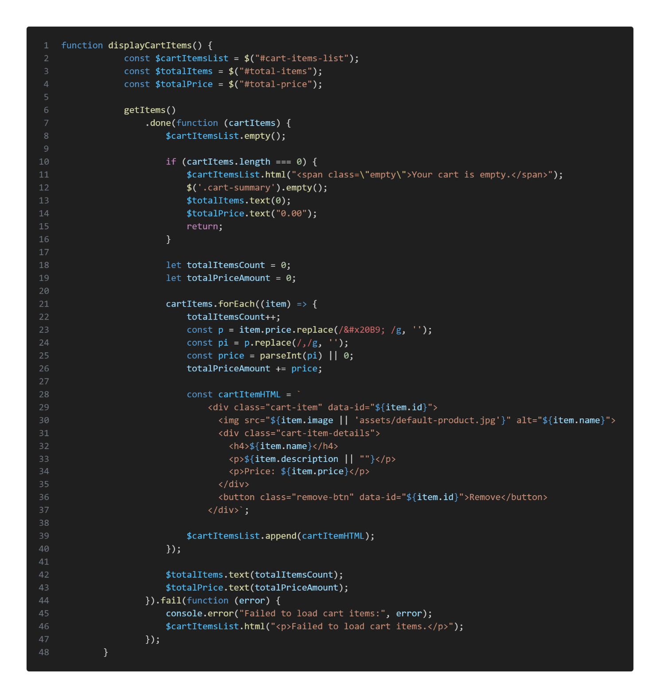

1. 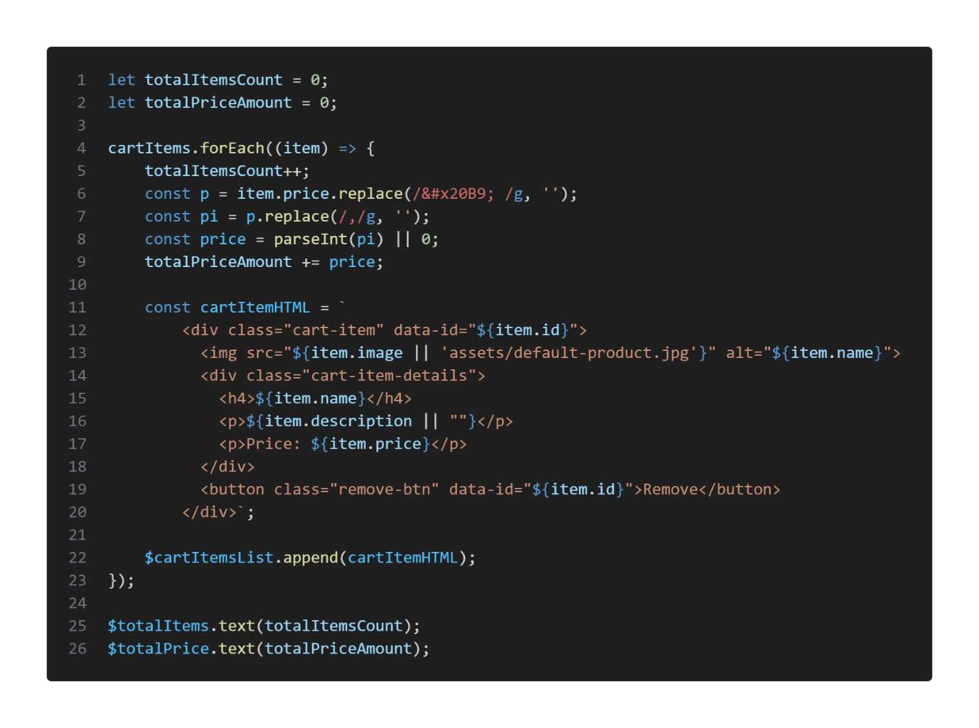**Calculating Total Price**: The total price of the cart is calculated based on the quantity of each item. A simple loop iterates through the cart array and computes the sum of all products in the cart.
2. **Responsive Features**: JavaScript ensures that the cart updates correctly across different devices and screen sizes, maintaining a seamless experience as users interact with the website.

* 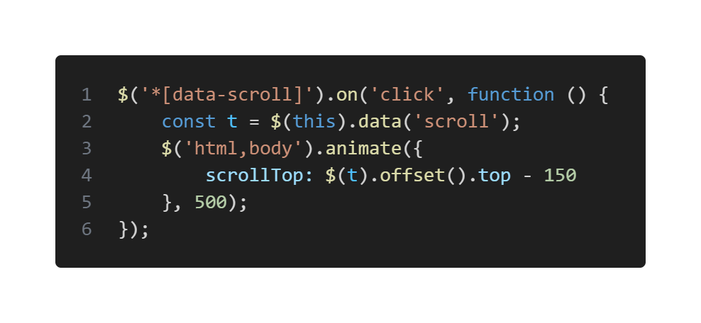**Scrolling to elements using JavaScript**
* 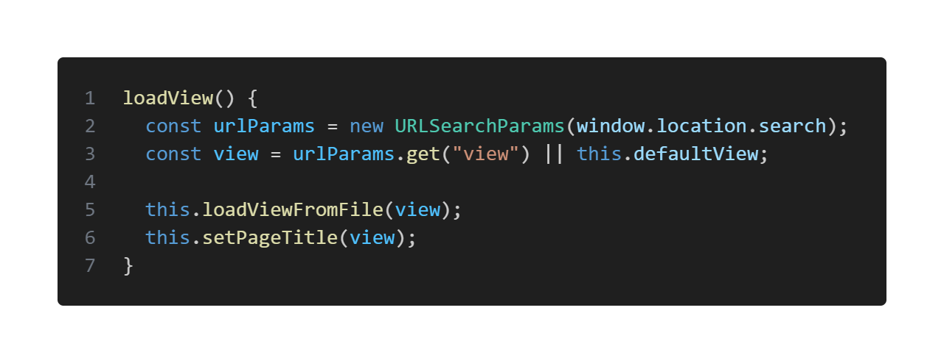**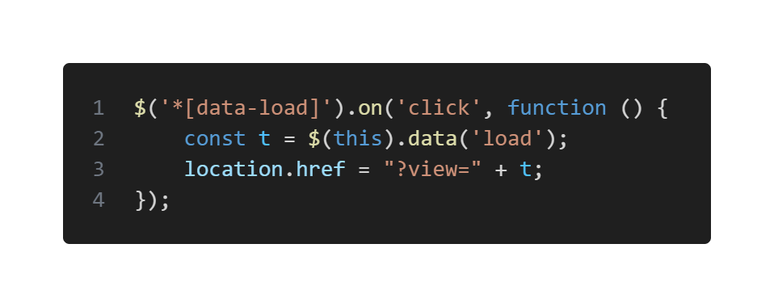Navigating to pages**
* **Implementing SPA**

## Using JSON for data Storage

For this project, JSON is used as a lightweight and flexible way to represent product data and other information on the website. JSON is ideal because it can easily be parsed and used in JavaScript, making it a good fit for front-end applications that do not require a back-end database.

**JSON Structure**:

Each product on the website is represented as an object in JSON. These objects include relevant attributes like name, description, price, and image. The entire product list is stored in an array of objects.

This JSON data is either fetched from a local file or stored within the JavaScript itself (as a string) to simulate data loading. The data for each product is structured with key-value pairs, which makes it easy to access and modify.

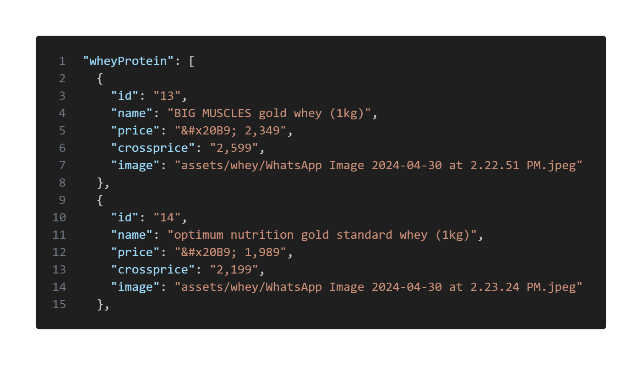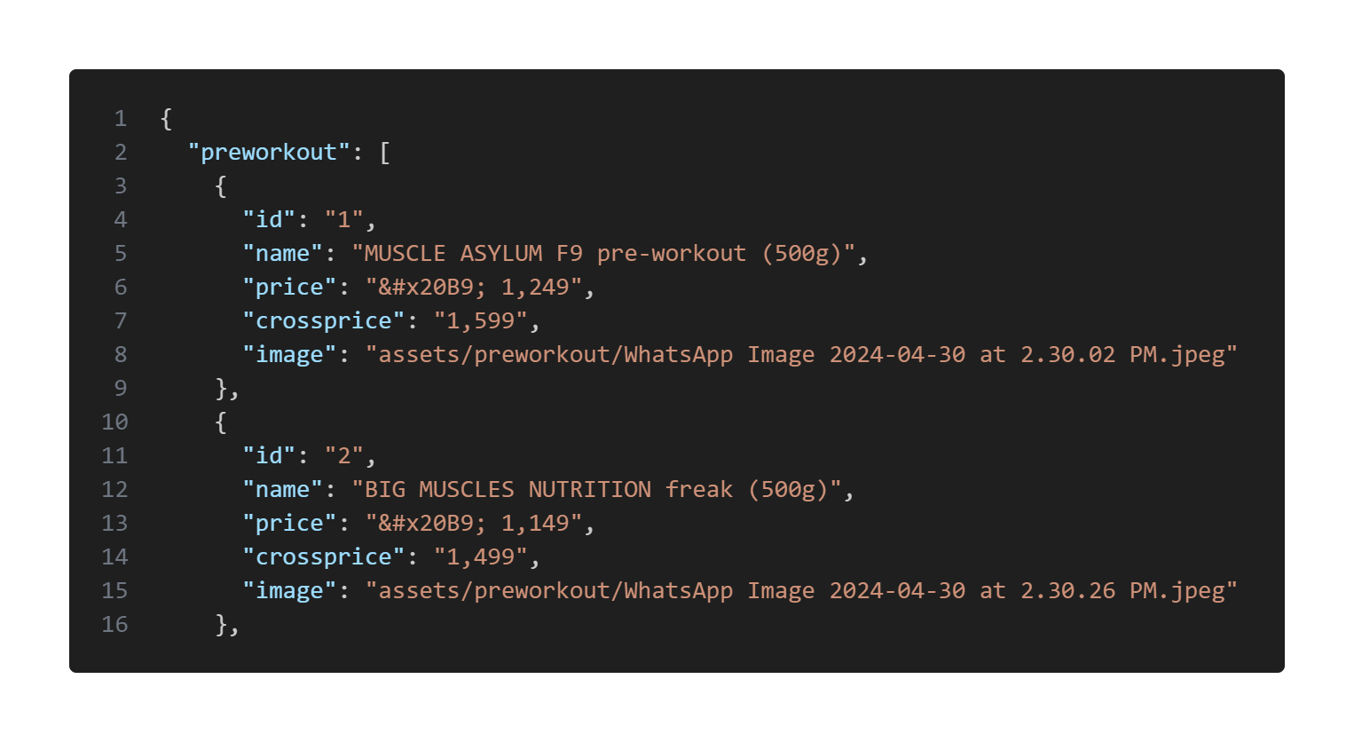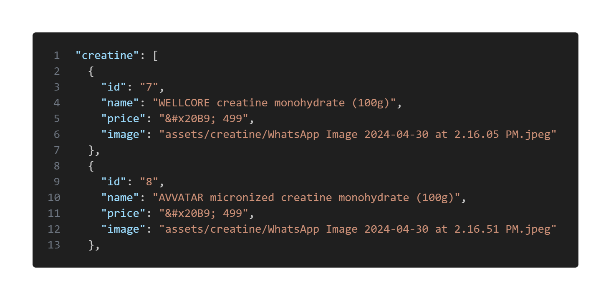

**Advantages of Using JSON**

1. **Lightweight and Flexible**: JSON is easy to read and write, which makes it a practical choice for handling small to medium amounts of data without a back-end database.
2. **Easy to Parse**: JSON data can be easily parsed by JavaScript, making it simple to integrate with client-side applications.
3. **Interoperability**: JSON is a widely used format and can be used for future scalability (if back-end integration is needed) or to communicate with other systems in the future.

**Challenges and Considerations**

* **Data Persistence**: Since the project does not have a back-end, data is not persisted across sessions. To solve this, cart data can be stored in the browser's local storage.
* **Dynamic Content**: Handling dynamic content like adding/removing products from the cart requires careful management of the JSON data structure to ensure consistency between the UI and the underlying data.

Using JSON in this project allows for easy storage and manipulation of product and cart data. It integrates seamlessly with JavaScript to dynamically update the user interface without needing a back-end database. While this implementation is ideal for a front-end-focused project, it can be extended in the future to include server-side storage if the project were to be scaled.

## Challenges faced during implementation

* **Responsive Design**: One of the challenges was ensuring the website looked good on all devices, which was achieved using media queries and flexible grid systems.
* **Interactivity**: Adding the dynamic behaviour of the cart (adding, updating, and removing products) required careful handling of JavaScript functions to ensure smooth interaction.
* **Cross-browser compatibility**: Ensuring that the website functioned correctly on all major browsers required some trial and error, especially with JavaScript behaviour and CSS rendering.

## **Use of npm & Gulp in the project**

For the project **"Online Supplements Store"**, the use of **Gulp** and **npm** was implemented to enhance the efficiency and maintainability of the development process. These tools were utilized to automate critical tasks such as minifying CSS and JavaScript files, optimizing images, and managing project dependencies seamlessly. This approach ensured that the project adhered to modern web development standards, resulting in faster load times, reduced file sizes, and an overall optimized build.

Gulp served as the task runner to streamline repetitive tasks, while npm facilitated the management of essential libraries and packages required for the project. By integrating these tools, the development workflow was not only simplified but also made scalable, allowing for easier updates and future enhancements to the project.

This methodology reflects a commitment to efficient coding practices and highlights the importance of leveraging modern tools to deliver a high-quality user experience.

## **Conclusion**

The implementation of the "Online Supplements Store" project successfully achieved the main objectives of providing a user-friendly platform for browsing and purchasing supplements. HTML, CSS, and JavaScript were utilized effectively to create an interactive and aesthetically pleasing website. While no back-end features were included, the front-end functionality, including the shopping cart and total price calculation, provides a solid foundation for further development if the project were to be expanded into a full-fledged e-commerce platform in the future.

# Results

## Home page

## About page

## Contact page

## User Account page

## Empty Cart view

## Added items in cart view

## Product Detail view

# Conclusion

The project titled **"Online Supplements Store"** successfully demonstrates the creation of an interactive and user-friendly webpage that showcases various fitness supplements. This minor project, implemented using HTML, CSS, and JavaScript, aimed to provide a seamless shopping experience where users can explore products, view their details, and add them to their cart.

Throughout the project, we focused on designing a responsive and aesthetically pleasing interface to enhance user engagement. JavaScript was utilized to handle dynamic features like adding items to the cart and calculating totals, ensuring a smooth and functional user experience. Additionally, the use of JSON for storing product data helped simplify the representation and retrieval of information, making the system modular and easy to extend in the future.

While the project does not currently include back-end functionalities, such as order processing or user authentication, it lays a strong foundation for future scalability. Integration of back-end systems and database connectivity can transform this project into a fully operational e-commerce platform.

This project provided invaluable learning opportunities, including hands-on experience in web design, client-side scripting, and structuring data. It also enhanced our problem-solving and debugging skills, preparing us for more complex developments in the field of web applications. The success of this project reflects a strong understanding of fundamental web development concepts and highlights its potential for real-world applications.

# References/ Bibliography

1. **Books**
   * Duckett, Jon. *HTML and CSS: Design and Build Websites*. John Wiley & Sons, 2011.
   * Duckett, Jon. *JavaScript and jQuery: Interactive Front-End Web Development*. John Wiley & Sons, 2014.
   * Freeman, Elisabeth. *Head First HTML and CSS*. O'Reilly Media, 2012.
   * McFarland, David Sawyer. *CSS: The Missing Manual*. O'Reilly Media, 2015.
2. **Web Development Learning Platforms**
   * W3Schools – Comprehensive tutorials and references on HTML, CSS, and JavaScript.
   * MDN Web Docs – Authoritative resource for web standards and coding practices.
   * freeCodeCamp – Interactive learning platform for coding fundamentals and projects.
3. **Technical Blogs and Websites**
   * CSS-Tricks – Guides and examples for mastering CSS.
   * A List Apart – Insights into web standards and user experience.
4. **Tools and Resources Used**
   * JSON Placeholder for understanding and practicing JSON structures (https://jsonplaceholder.typicode.com).
   * Visual Studio Code – Code editor for web development.
   * Google Chrome Developer Tools – For debugging and testing the webpage.
5. **Other Sources**
   * GitHub – Repository for open-source web development projects and collaborative learning.
   * Stack Overflow – Forum for solving specific coding challenges and seeking community help.

These references reflect the diverse resources consulted to ensure a well-researched and robust foundation for developing the project **"Online Supplements Store."**